Free Shuttle Bus Service on weekends

(Ishizuchi Tsuchiigoya – Omogo Gorge – Shikoku Pilgrimage Temples)

Due to the suspension of the Iyotetsu- Nanyo Bus Omogo service

From Oct. 4th to Nov. 30th 2025, a free shuttle bus will temporarily operate to ensure transportation access for tourists visiting Mt. Ishizuchi, Omogo Gorge and Shikoku pilgrimage temples (No. 44 and 45)

■ Operating Period:

Saturdays, Sundays, and public holidays ONLY

From October 4th 2025 (Sat) to November 30th 2025 (Sun)

■ Operator: Mikawa TAXI 　／ TEL: 0892-21-0023

■ Routes and Timetable:

(Outbound)

 KUMA Bus Depot → Ishizuchi Tsuchigoya

08:00 – 09:39

13:30 – 15:09

(Return)

Ishizuchi Tsuchigoya → KUMA Bus Depot

09:50 – 11:29

15:15 – 16:54

*【Timetable】*

■ Operation Details:

• Passengers can also get on and off at each stops.

■ Notes for Passengers:

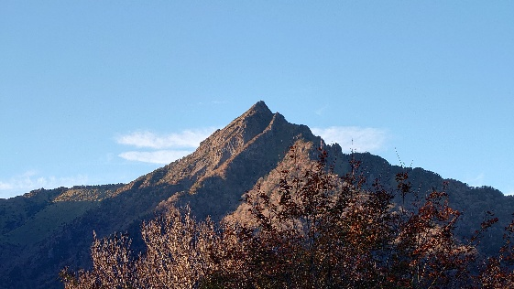• Maximum seating capacity is 9 passengers.